INTELLIGENT INVESTING Daily NEWSLETTER
  - Stock markets, cryptos, gold, miners & OIL
  - etf, crypto & magnificent 7+ trade alerts

BY Dr. ARNOUT TER SCHURE & ASSOCIATES, 10/24/2025
This is a working document. Once the link has been emailed out, you can check back at any time to see if it has been updated by checking the timestamp: last updated on 10/26 at 3:55 PM PST

tablE of contentS
All our posts on X, which often include bonus charts and trade setups, are available here.

STOCKMARKETS 1I
SP500 1I
NASDAQ100 V
DOW JONES VIII
SMALL CAPS IX
SEMI CONDUCTORS X

CRYPTO CURRENCIES XI
BITCOIN XI
ETHE XII
RIOT XIII

GOLD, MINERS & OIL XIV
GOLD XIV
GDX & GDXJ XV

ETF TRADE ALERTS XVI
MAGNIFICENT 7+ TRADE ALERTS XVII
CRYPTO TRADE ALERTS XVIII

TRADING IS BORING – JUST THESE RULES, MA’AM & OUR CURRENT POSITIONS XIX
BACKTESTED TRADING SYSTEM PERFORMANCES XX
REFERAL PROGRAM XXI

STOCKMARKETS
SP500
The bears failed at every step of the way. With today’s new all-time high, they must concede, and a new W-5 rally to ideally 7120 is underway. This is why we have our warning levels and why we constantly say to focus on 7120, not the downside. This 4th wave disappointed miserably in that sense.
Besides, last week we nailed the first three moves perfectly —yay! But after that, it became a bit more hit-or-miss. For example, we correctly predicted the drop on Wednesday, which would give the bears their final fighting chance, but even TSLA’s earnings couldn’t do anything, and the market rallied unabated on Thursday.
Thus, W-4 was only a three-day event: October 10, 13, 14, with a failed W-c. Based on the short-term chart below, another diagonal 5th wave, ideally targeting 6890-6930, should be in progress. In a diagonal, the 3rd wave tends to reach the 123.6-138.2% extension. W-iv the 61.8-76.4% and W-v the 161.80-176.4%. But note the previous W-5 diagonal (with blue Fib extensions) in late September, where W-iii equals W-i, and W-v was barely at 123.6%. We bring it to your attention to underscore the “tends”. Thus, as waves truncate, they can also extend. Especially since a W-5 = W-1 targets 7124… See the next page.
The warning levels for the bulls on the hourly chart are raised to: 6772 (25% chance the W-5 uptrend is over), 6735 (50% chance), 6655 (75% chance), and 6553 (W-5 uptrend over).
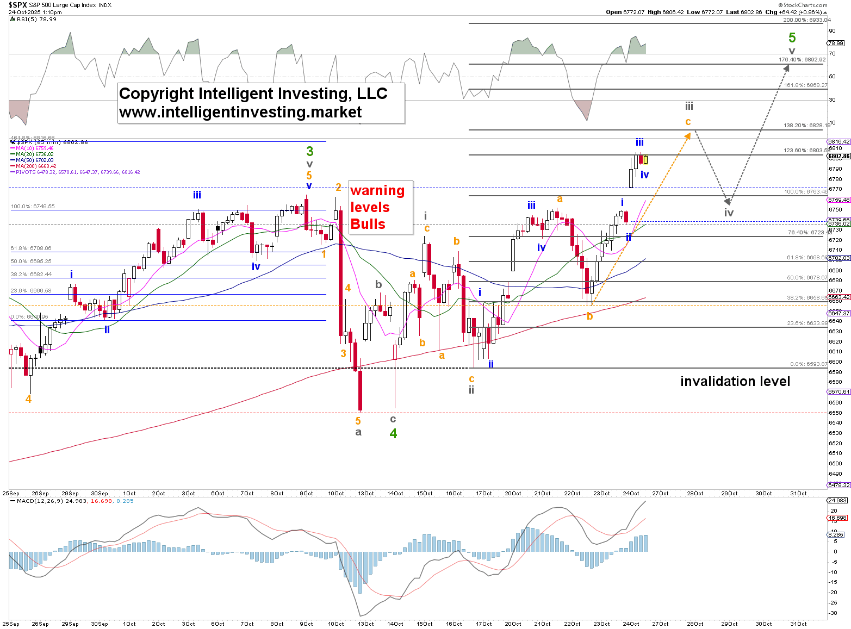
If we zoom out to the preferred daily chart— because the more scribbles we analyze, the more likely we are to make a mistake —we can count the index as also in W-3 of W-iii of W-5, etc. See the daily chart below. We simply don’t care about the intra-day ups and downs. As we can observe, the W-5 =W-1 targets the 7124 level, which has been our upside target for the W-c of W-3 for a very long time. Just as ~6800 for W-3 was our target for months, the W-4 unfortunately never fully reached the ideal 6400±100 target, bottoming at 6555 within 3 days, with a failed C-wave, which wrong-footed us, as we expected a more protracted W-b and W-c for W-4.
The warning levels for the bulls on the daily chart are raised to: 6772 (25% chance the W-5 uptrend is over), 6735 (50% chance), 6655 (75% chance), and 6553 (W-5 uptrend over).
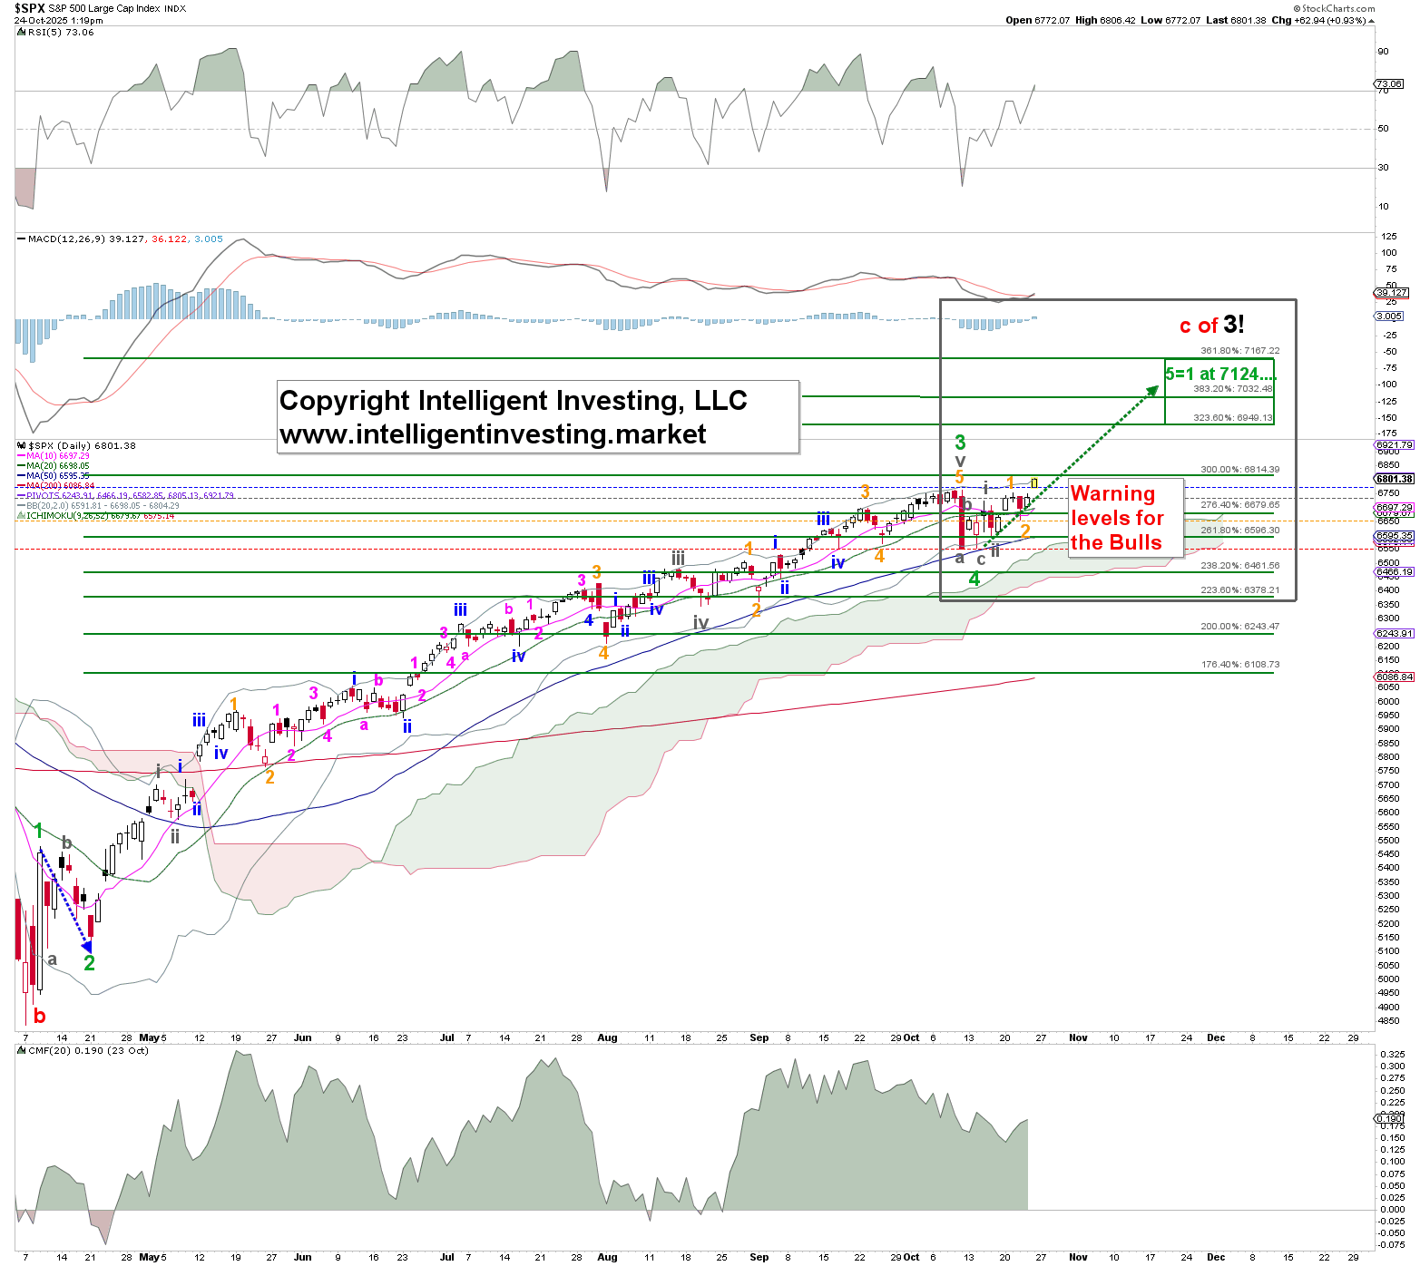

Speaking of preferred, the weekly chart is even better because it keeps our eye on the price (7120) and lets us see the forest for the trees. Namely, while the hourly chart required daily revisions because the hourly candles are more random —i.e., each new day has only a 53% chance of being green —we did not need to change the weekly chart at all, except that the W-4 was shallower than expected. But with the down week two weeks ago, we can account for it. Thus, the green W-5 is underway, targeting ideally ~7120, contingent on the index holding above the following RAISED price levels: 6655 (25% chance the W-3 uptrend is over), 6550 (50% chance), 6343 (75% chance), and 6212 (W-3 uptrend over).
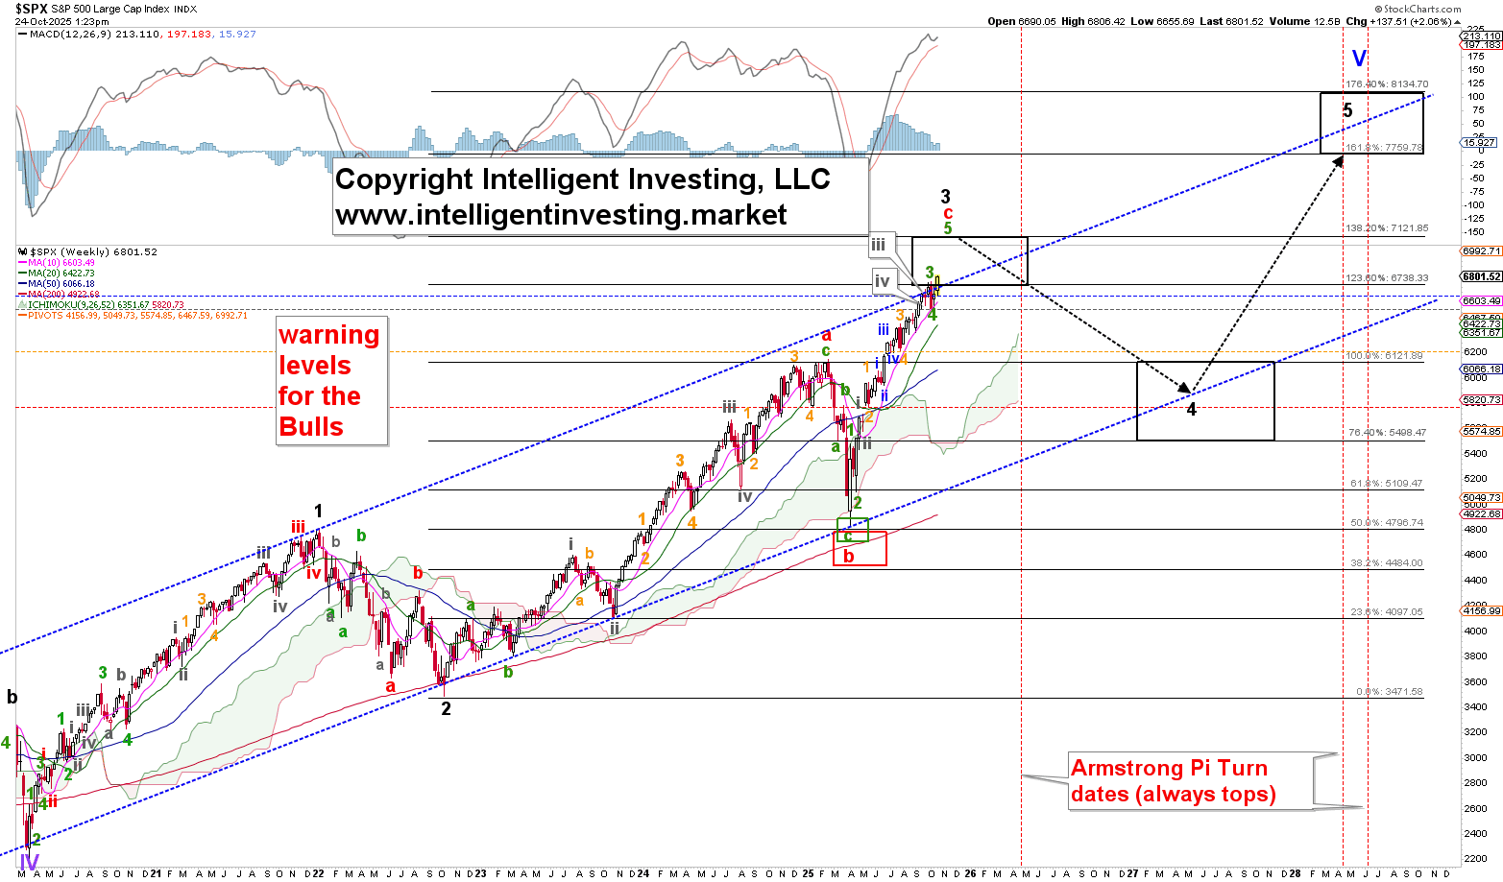

NASDAQ100
The bears failed at every step of the way. With today’s new all-time high, they must concede, and a new W-5 rally to ideally ~26880 is underway. This is why we have our warning levels and why we constantly say to focus on 26880, not the downside. This 4th wave disappointed miserably in that sense. Besides, last week we nailed the first three moves perfectly —yay! But after that, it became a bit more hit-or-miss. For example, we correctly predicted the drop on Wednesday, which would give the bears their final fighting chance, but even TSLA’s earnings couldn’t do anything, and the market rallied unabated on Thursday, morphing the possible five waves lower we were tracking into only three… And that’s corrective.
Thus, W-4 was only a three-day event: October 10, 13, 14, with a failed W-c. Based on the short-term chart below, another diagonal 5th wave, ideally targeting 25680-25960, could be in progress. In a diagonal, the 3rd wave tends to reach the 123.6-138.2% extension. W-iv the 61.8-76.4% and W-v the 161.80-176.4%. But note the previous W-v diagonal (with orange Fib extensions) in late September, where W-3 equals W-1, W-4 dropped to the 50% extension, and W-5 was barely at 123.6%. We bring it to your attention to underscore the “tends”. Thus, as waves truncate, they can also extend. Especially since a W-5 = W-1 targets 26543-26863… See the next page. The warning levels for the bulls on the hourly chart are raised to: 25288 (25% chance the W-5 uptrend is over), 24988 (50% chance), 24652 (75% chance), and 24207 (W-5 uptrend over).
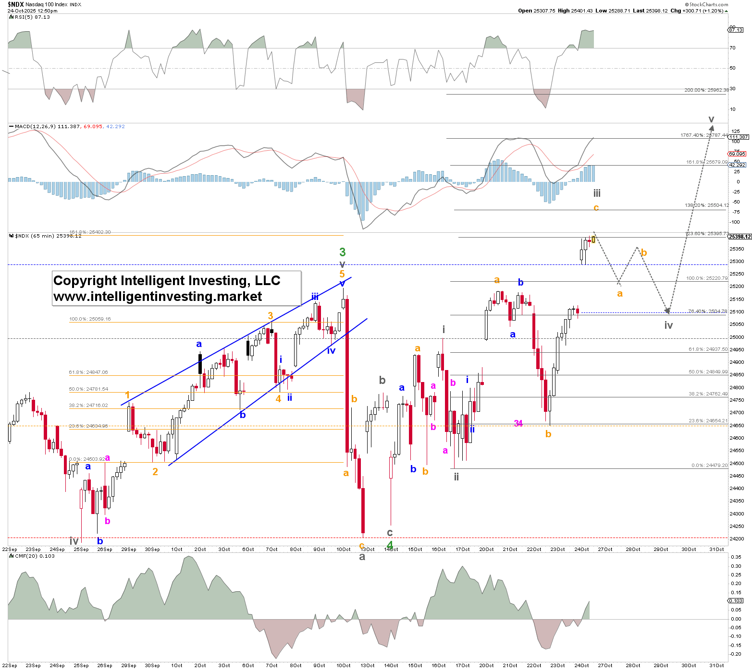
If we zoom out to the preferred daily chart—because the more scribbles we analyze, the more likely we are to make a mistake—we can count the index as also in W-3 of W-iii of W-5, etc. See the daily chart below. We simply don’t care about the intra-day ups and downs. As we can observe, the W-5 =W-1 targets the 26680 level, which has been our upside target for the W-c of W-3 for a very long time. Just as ~25250 for W-3 was our target for months, the W-4 unfortunately never fully reached the ideal 23500±500 target, bottoming at 24256 within 3 days, with a failed C-wave, which wrong-footed us, as we expected a more protracted W-b and W-c for W-4.
The warning levels for the bulls on the daily chart are raised to: 25288 (25% chance the W-5 uptrend is over), 24988 (50% chance), 24652 (75% chance), and 24207 (W-5 uptrend over).
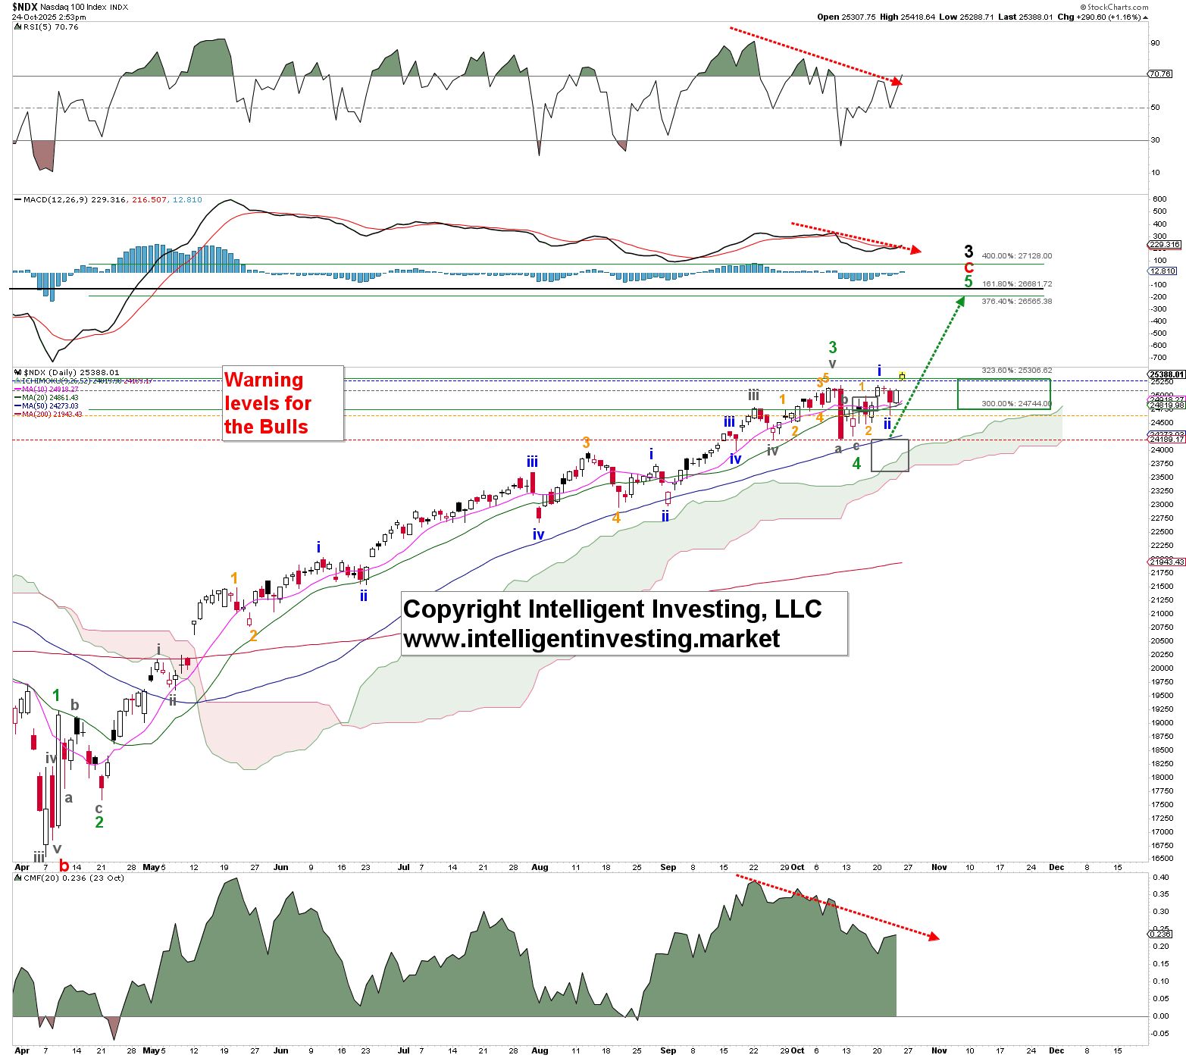

Speaking of preferred, the weekly chart is even better because it keeps our eye on the price (~26680) and lets us see the forest for the trees. Namely, while the hourly chart required daily revisions because the hourly candles are more random — i.e., each new day has only a 53% chance of being green — we did not need to change the weekly chart at all, except that the W-4 was shallower than expected. But with the down week two weeks ago, we can account for it.
Check out the path we outlined since this summer: gray down arrow, gray up arrow, green down arrow, green up arrow. We’ve so far completed all of that, with the final green up arrow underway. Perfect! That’s what we focus on.
Thus, the green W-5 is underway, targeting ideally ~26680, contingent on the index holding above the following RAISED price levels: 24652 (25% chance the W-3 uptrend is over), 24207 (50% chance), 22977 (75% chance), and 22222 (W-3 uptrend over).
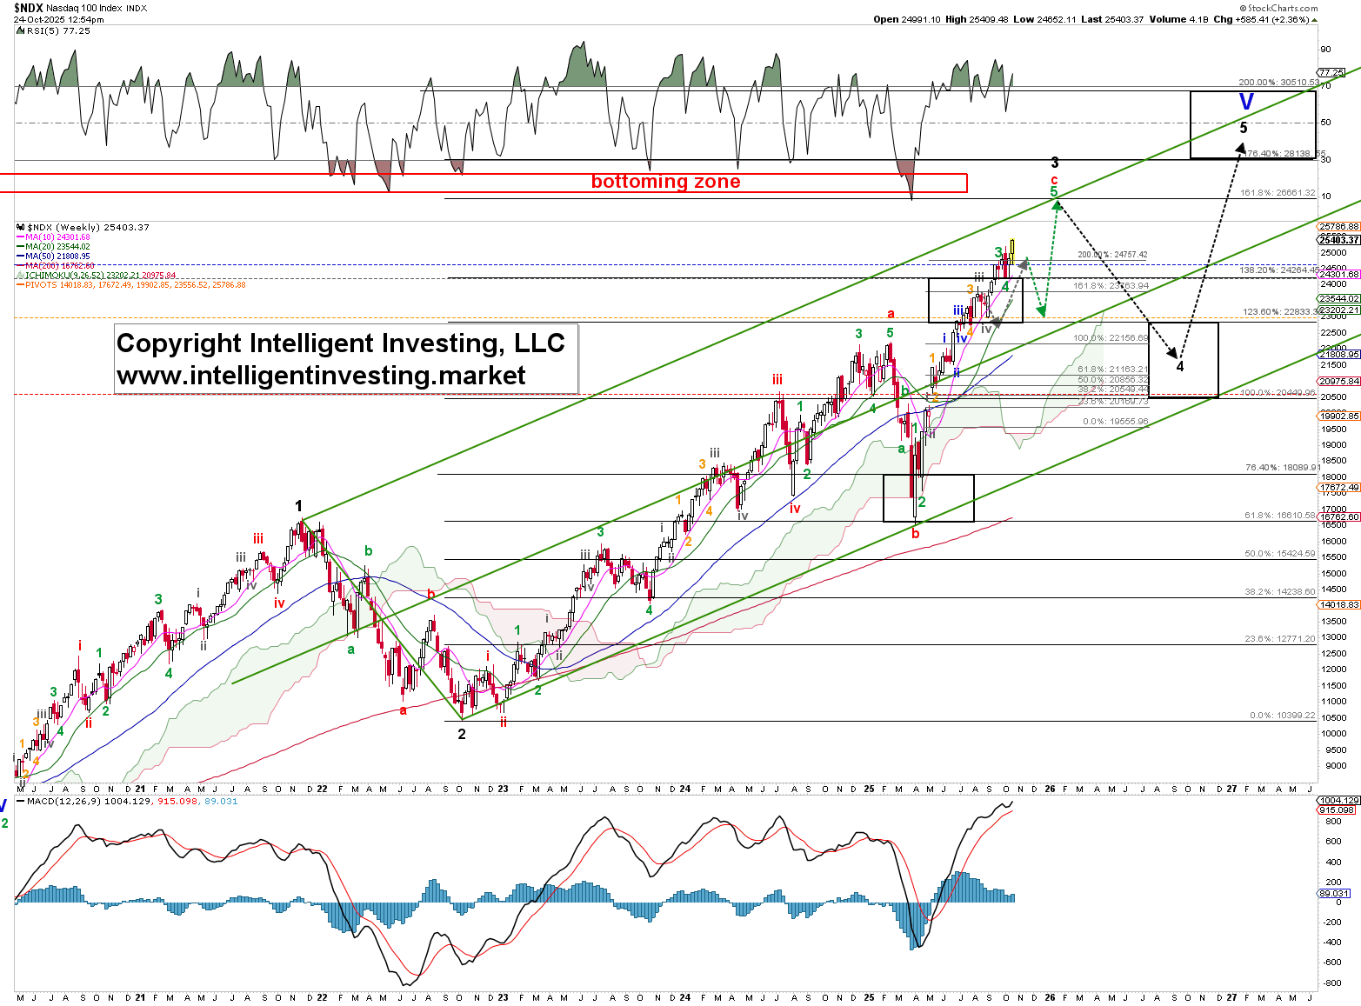

DOW JONES INDUSTRIAL AVERAGE
The market forces our hand, and we must accept that the W-ii/b bottomed on October 14, and W-iii/c is now underway. The warning levels for the Bulls are raised to: 46941 (25% chance the W-iii/c uptrend is over), 46706 (50% chance), 46461 (75% chance), 45781 (the W-iii/c uptrend over).
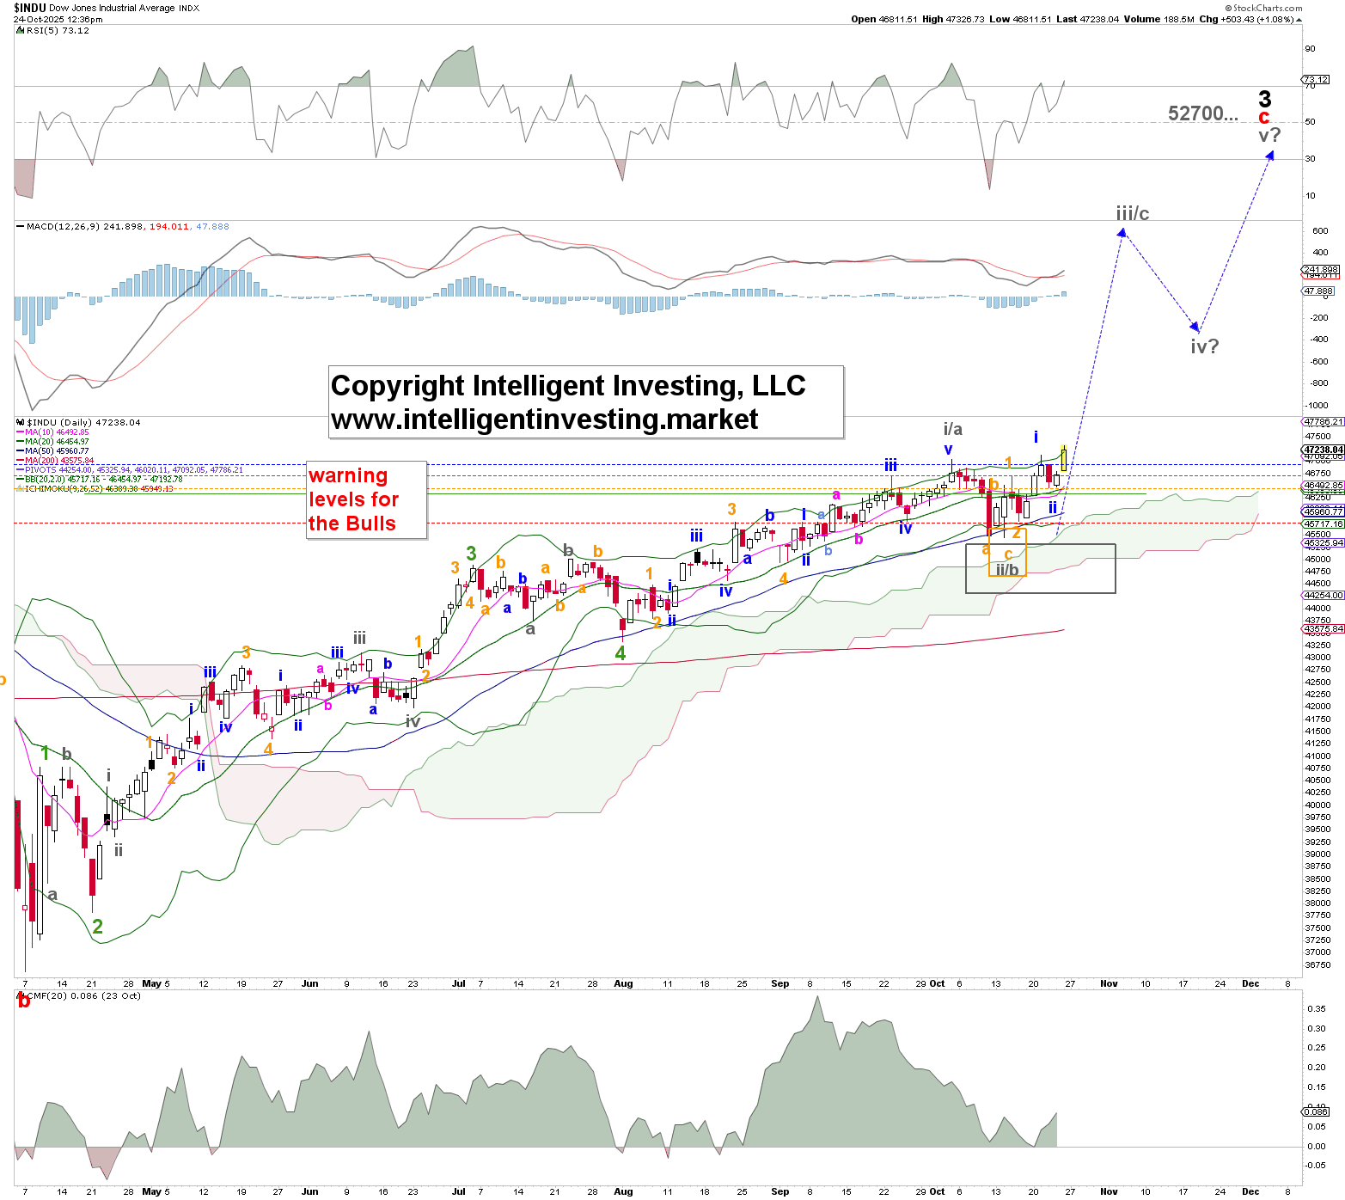

SMALL CAPS
Bigger picture, we were looking for higher (W-iii to ideally ~1575), and we were simply trying to figure out how the index would get there. Now we have our answer, W-iii of W-3 of W-iii is now underway, while we remain focused on 1576, contingent on the index holding above the raised warning levels for the Bulls: 1475 (25% chance the W-iii uptrend is over), 1464 (50% chance the uptrend is over), 1440 (75% chance), 1425 (the uptrend over).
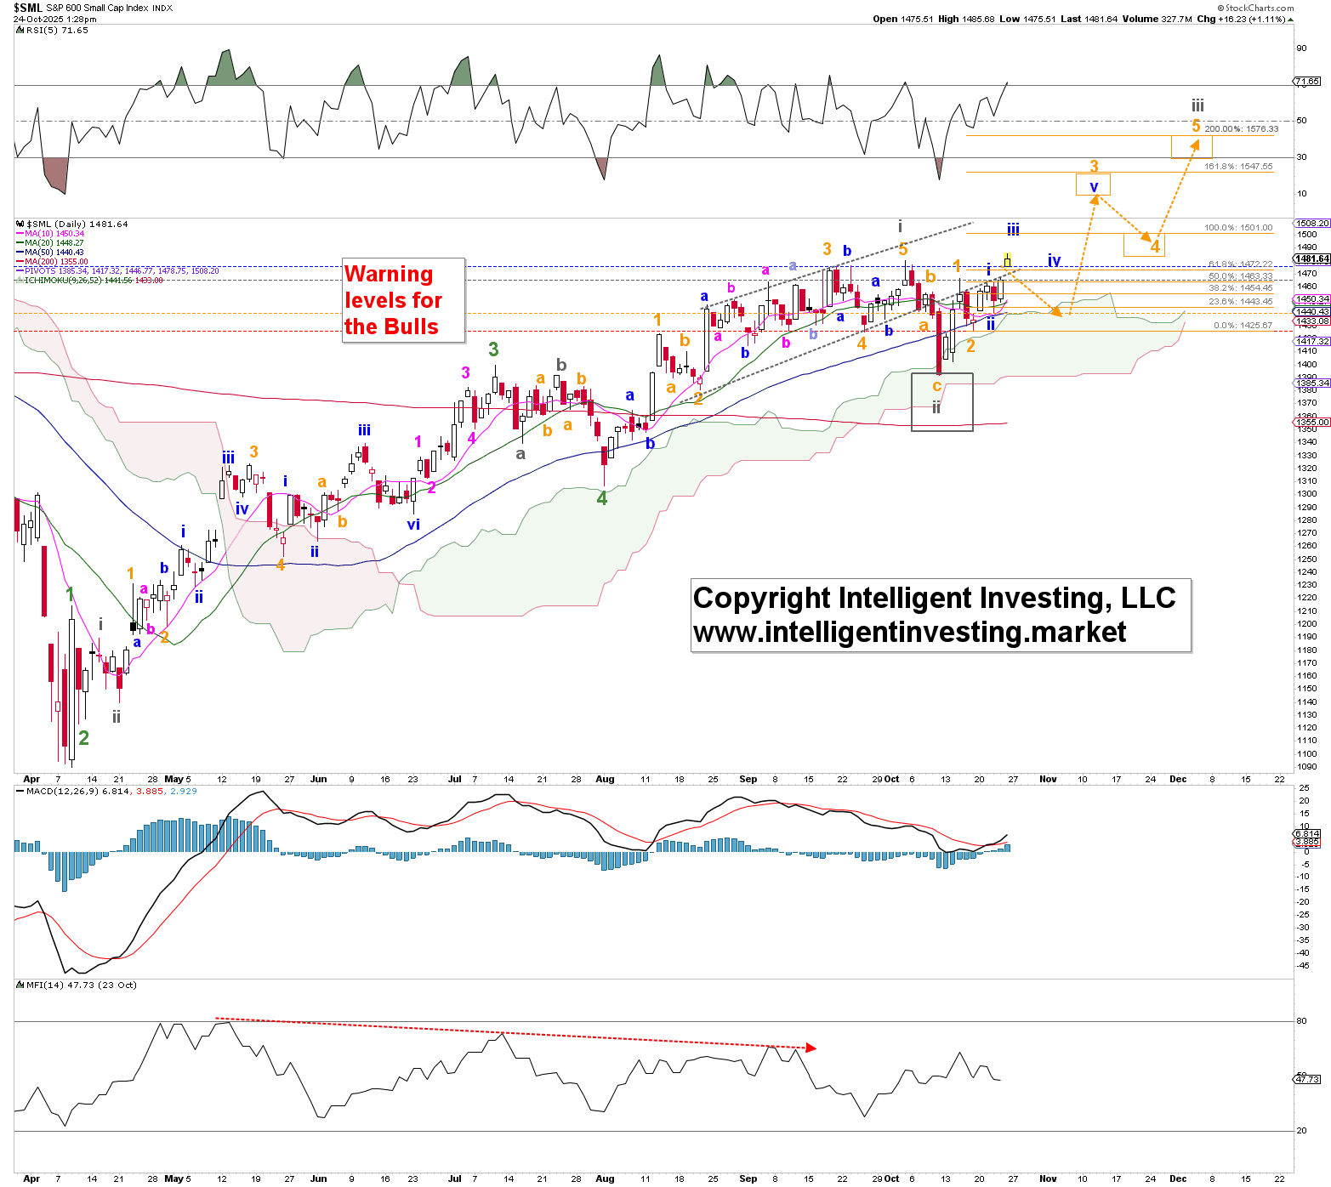

SEMI CONDUCTORS
On Wednesday, we found “An overlapping diagonal is in place from the October 10 low. We do not yet know whether this is a leading diagonal (1st wave of W-v) or an ending diagonal, but given the numerous negative divergences (even if only a condition), we favor the latter. The bears stepped up and broke the index’s price below the second warning level. Now, we need to see a break below the third to signal the start of the red W-iv. Otherwise, we’re in the W-1, 2 scenario even though overall, there are now enough (gray) waves in place to consider the red W-iii complete, but 5th waves can easily extend, aka subdivide (See GLD, GDX for example).”
Well, what we favored didn't happen, and the W-1, 2 (subdividing W-v) scenario is now confirmed. Welcome to a bull: upside surprises, downside disappointments! But we had our alternative ready, so there were no real surprises.
Thus, the warning levels for the Bulls remain at: 6961 (25% chance the uptrend is over), 6861 (50% chance the uptrend is over), 6648 (75% chance), 6547 (the uptrend over).
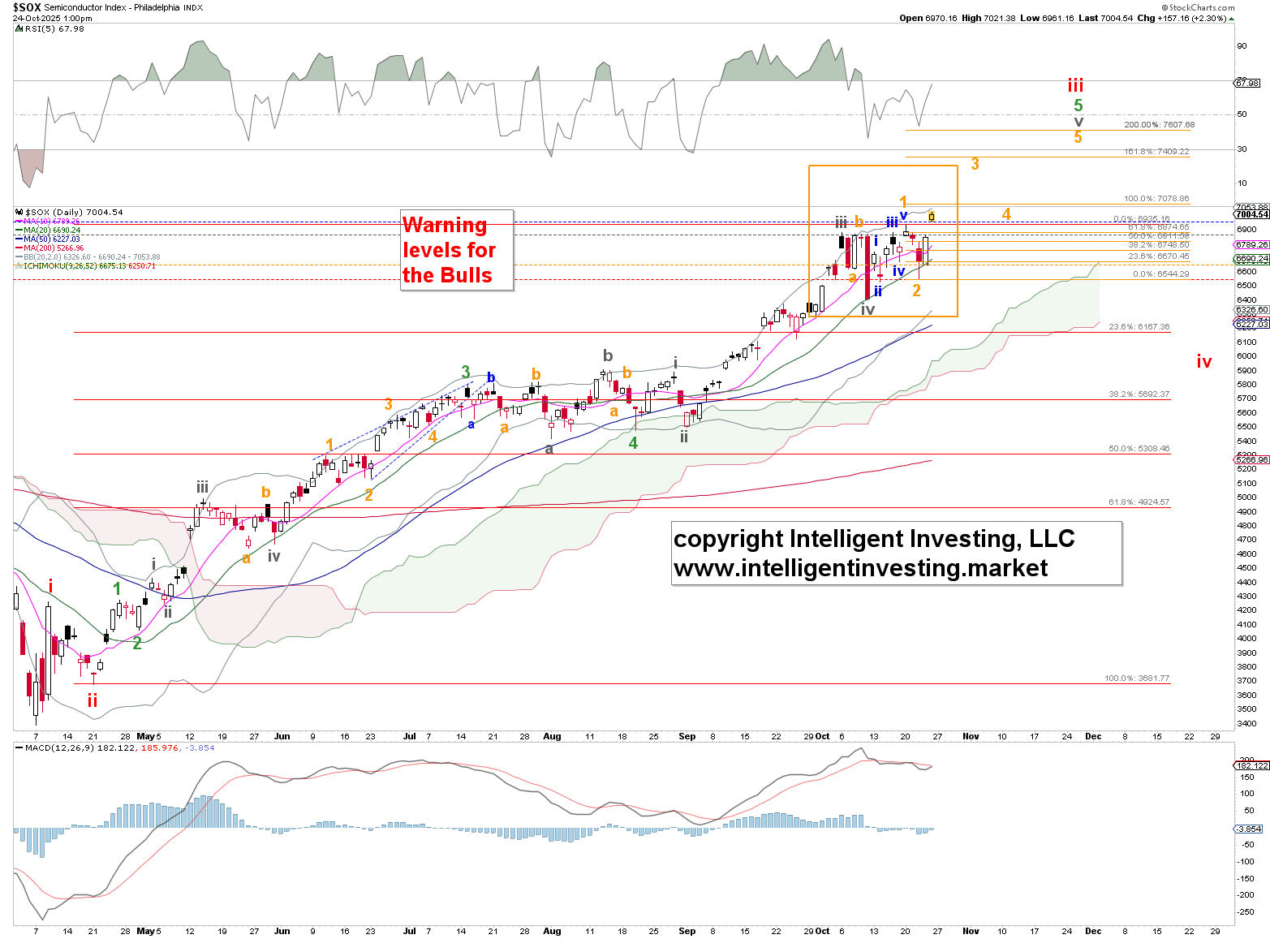

CRYPTOCURRENCIES
BITCOIN
Often it helps NOT to stare at the charts all day, and yesterday's, albeit involuntary, break did just that. As such, we have adjusted the price chart to the W-iii, W-iv scenario, aligning it with Ethereum’s. It makes more sense compared to the previous W-iv, 1, 2 (of W-v) setup, since BTC topped at the 223.6% extension of W-i, measured from W-ii, which is typical for an extended 3rd wave. Besides, it hasn't really gone anywhere over the last 3-4 months. Classic 4th-wave behavior, as all prior major tops saw BTC decline significantly within such a time frame. Moreover, a 4th wave typically bottoms out between the 23.6-38.2 retracement of W-iii: $101012-86471. So far, so good. A W-v = W-i can now target the 300.0% extension at $216440.
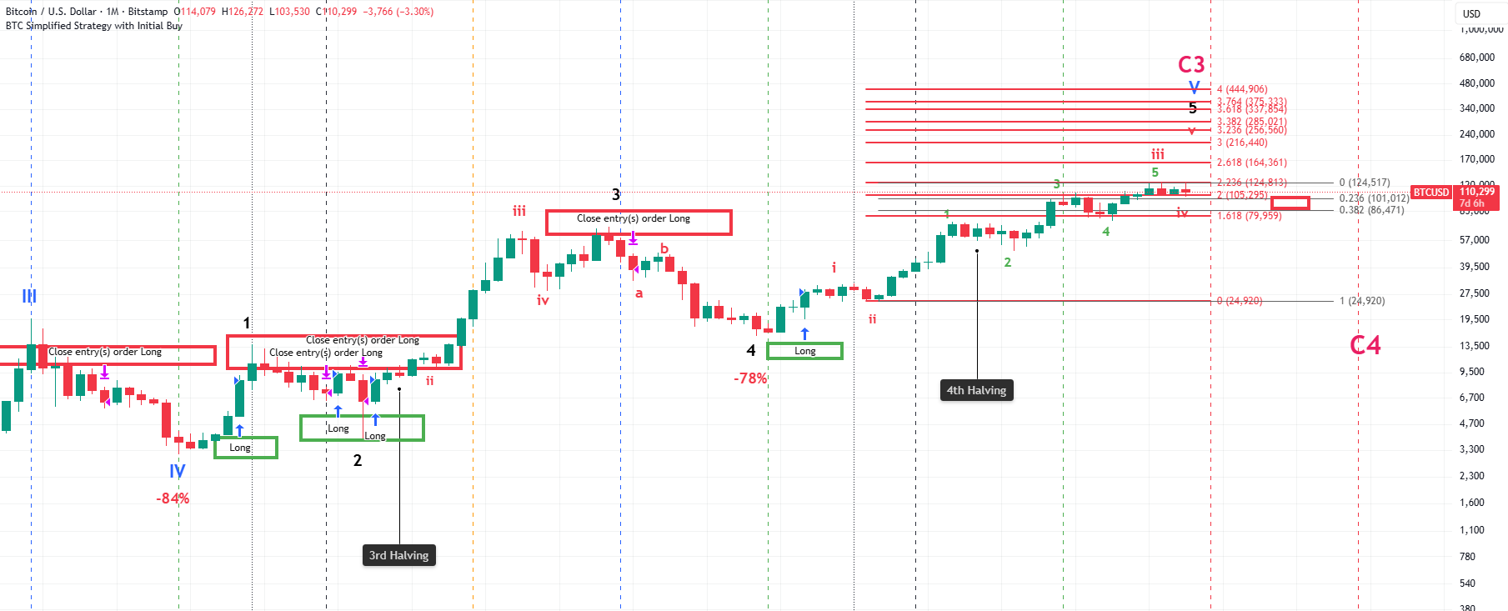
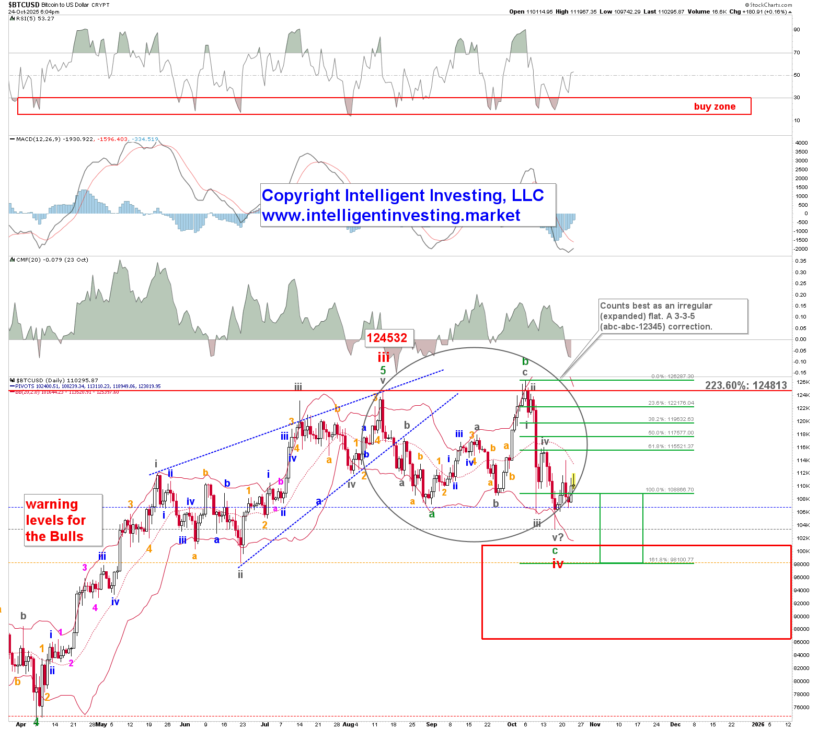
Besides, the short-term price action since the August high, 124532 vs 223.6 @ 124813(!), still counts best as an irregular expanded flat (c>b>a). See the daily chart on the left. And flat corrections are typical for 4th waves. The ideal target zone for the W-c of W-iv is 108866-98100, and that’s where BTC bottomed at: c = 1.236x a = 104772 vs. the 103552 low on October 17.
Lastly, this will make the April-August high an ending diagonal. When diagonals are complete, the price will often drop back to the beginning of the formation of that pattern. In this case, that is the W-ii at 98264. So far, this is what the market has essentially done. Thus, as we cannot exclude a subdivision of the W-c lower, there are enough waves in place (five) to consider W-iv as complete. Thus, the warning levels for the Bulls are set at: 106750 (25% chance the uptrend is over), 103552 (50% chance the uptrend is over), 98264 (75% chance), 74426 (the uptrend is over).
ETHEREUM
We can be very brief: we have not seen five waves up from the April low, and since Ether made a new ATH, we still expect that to be the case, targeting at least 6150. The past two months are still regarded as part of a sloppy, overlapping, confusing, shake-out-the-weak-hands 4th wave.
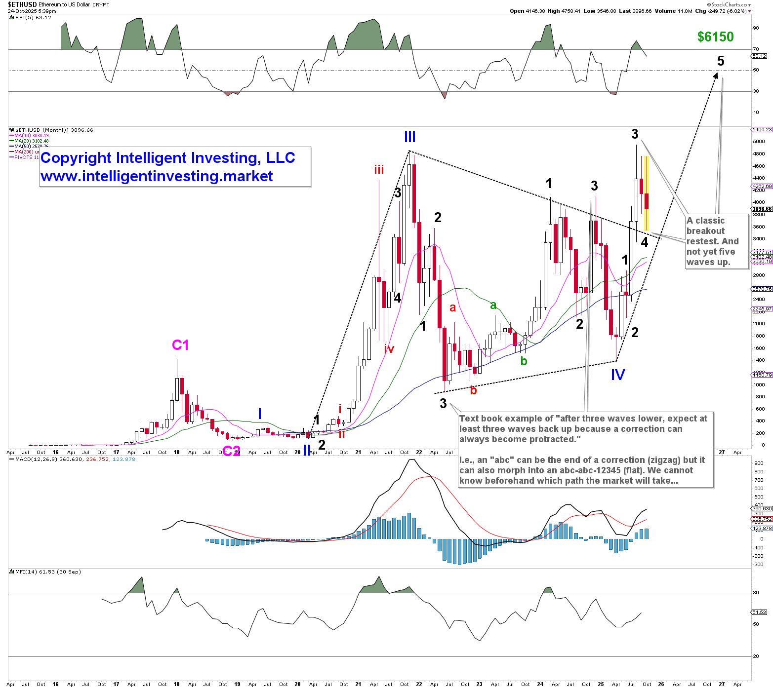

RIOT
The W-iv became protracted: after three waves down, we must always expect at least three waves back up. Why? Because an “abc” lower can morph into a larger “abc-abc-12345,” for example, which is what RIOT did, and it most likely bottomed out for W-iv on Wednesday, as we stated on Wednesday, “A close above yesterday’s high will go a long way to confirm the red W-v.” That is what happened yesterday, and contingent on holding above the warning levels, we see RIOT targeting $28+/-1.
The warning levels for the Bulls are set at: 20.90 (25% chance the W-v uptrend is over), 20.29 (50% chance), 19.15 (75% chance), 18.39 (the uptrend is over).
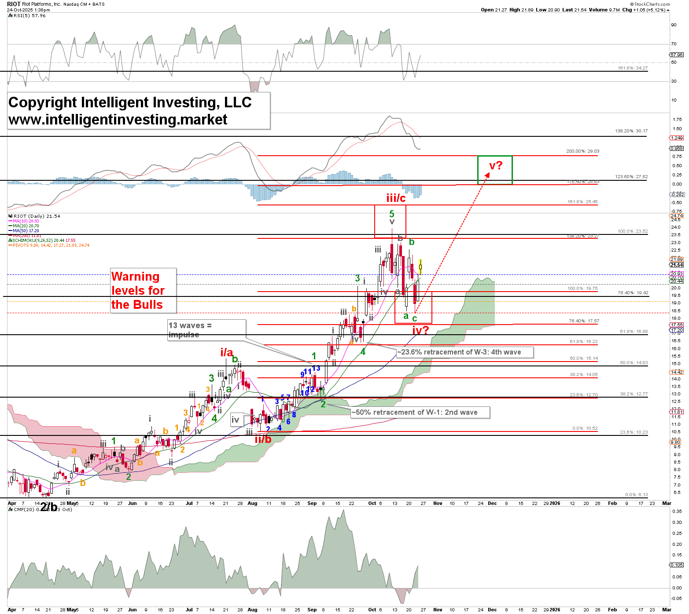

GOLD, MINERS & OIL
GOLD
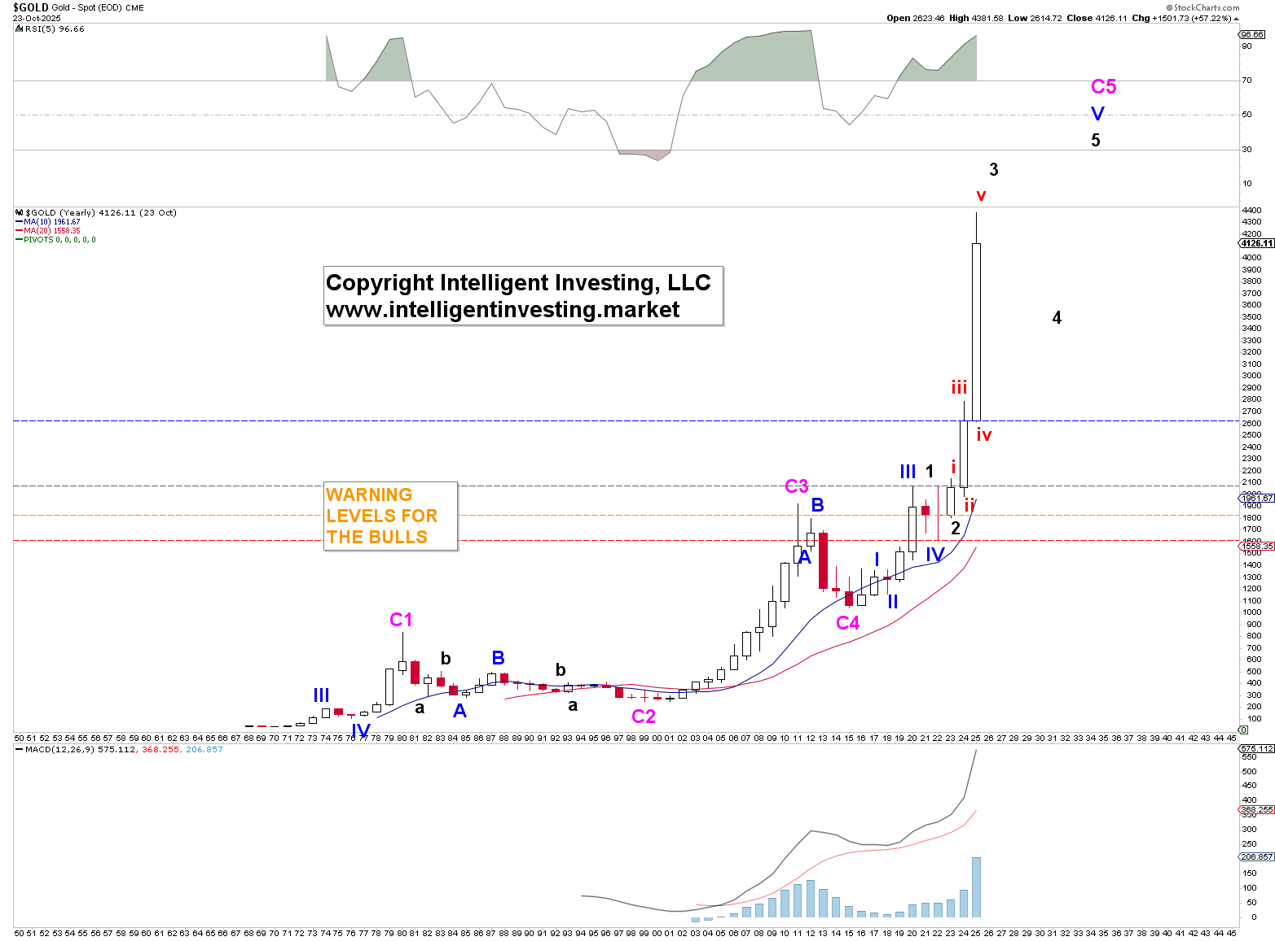
We continue with our big-picture overview now using the yearly chart (!) to show that a 3rd wave was in progress and the 4th wave is commencing. Nothing about the yearly chart tells us that GOLD has topped yet.
Remember, zooming out is always important, so we see the forest for the trees!
In fact, we’re also showcasing our weekly chart (see below), which we haven’t shared in a while, and it aligns with all our other charts (daily, monthly, yearly), adding weight to the evidence that W-4 is underway.
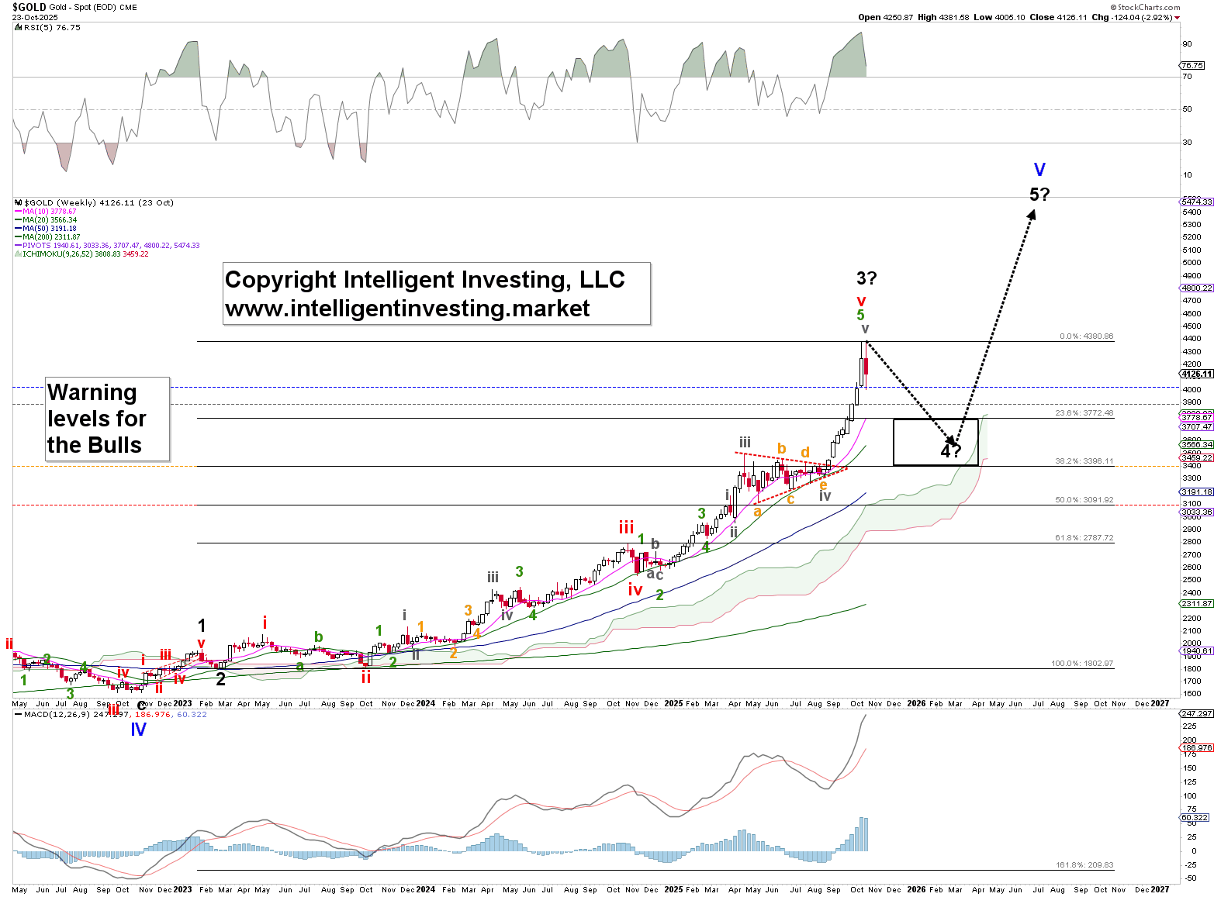
GDX & GDXJ
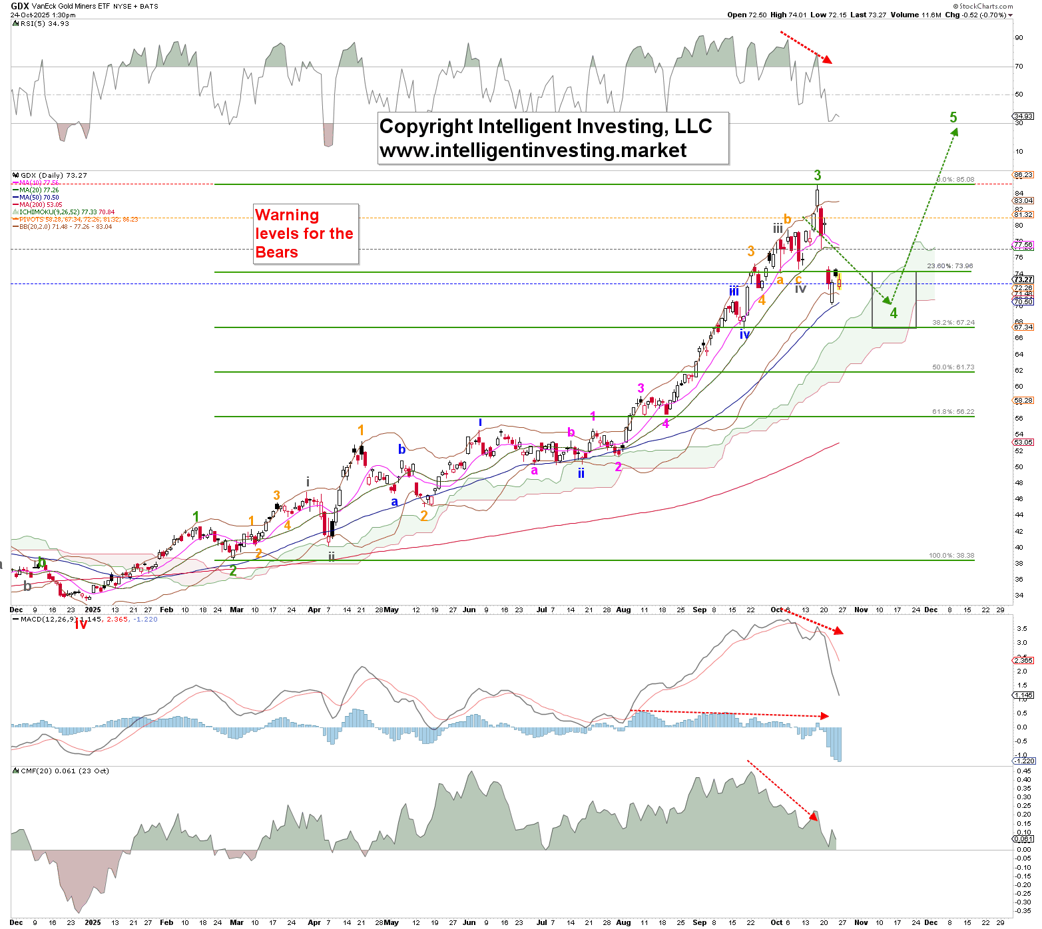
The 4th-wave pullback continues, and we still expect both miners to fill their respective gap-downs from this week, even if we get slightly lower prices first. In that case, the decline from the ATH will be five waves: W-a of W-4 and W-b will then commence, filling that gap
Remember that we believe the lower risk buying opportunities have arrived for those who can see further ahead than a few days… aka “from big time frames come big gains”

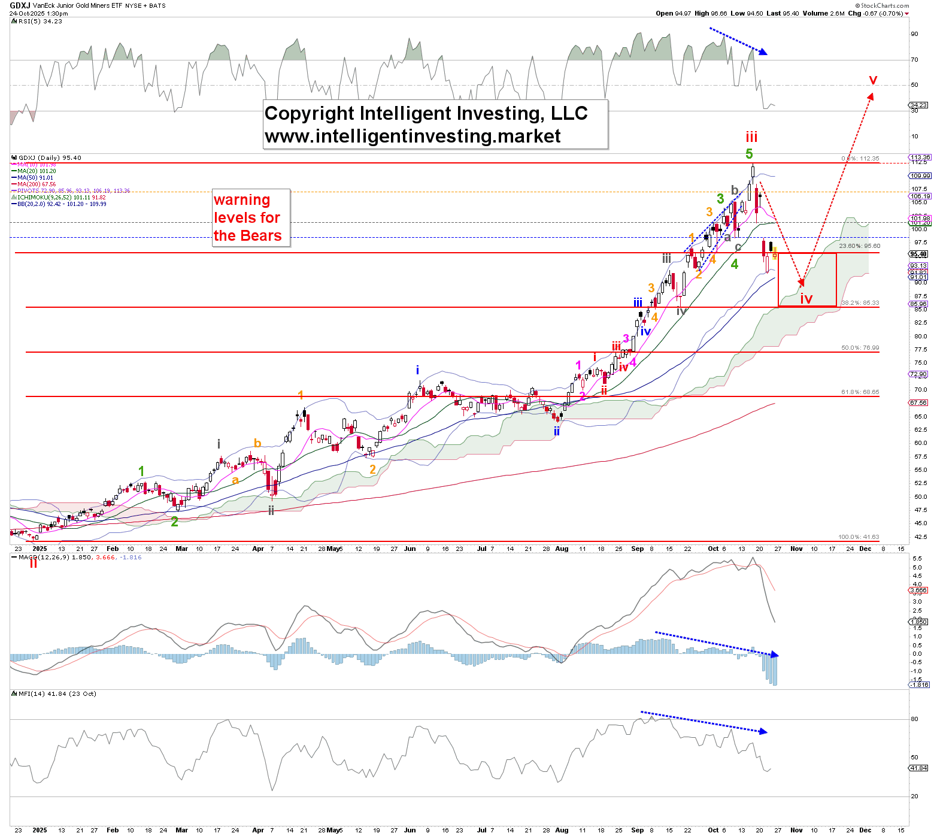

ETF TRADE ALERTS*
- Short-term System (EoD): Hold time is days to weeks. The trading signal is generated at the EoD.
- Intermediate-term System (EoW): Hold time is weeks to months. The trading signal is generated at the EoW.
- Long-term System (EoM): Hold time is months to years. The trading signal is generated at the EoM.
Green = BUY or SELL, Purple = Open Position (HOLD), Yellow = prior action . BUY or SELL), White = Stay in cash
DOW JONES* (DIA, other ETFs are DDM, UDOW)
- Short-term 10/24: HOLD the position bought 10/20. Buy signal was given at 46706.58. UP 1.1%
- Intermediate-term On 10/24: HOLD the long position bought 05/09. BUY signal given at $41249. UP 14.4%(!)
- Long-term On 09/30: HOLD the position bought 06/30. BUY signal given at 43948.56. UP 5.3%.
NDX* (QQQ, other ETFs are QLD, TQQQ)
- Short-term 10/24: HOLD the position bought 10/17. Buy signal was given at 24817.95. UP 2.2%
- Intermediate-term On 10/24: HOLD the position bought 05/02. BUY signal given at $20102.61. UP 26.4% (!).
- Long-term On 09/30: HOLD the position bought 05/30. BUY signal given at $21340.9. UP 15.6%
S&P500* (SPY, other ETFs are SSO, SPXL)
- Short-term 10/24: HOLD the position bought 10/20. Buy signal was given at 6735.13. UP 0.8%
- Intermediate-term On 10/24: HOLD the position bought 05/02. BUY signal given at $5686.67. UP 19.3% (!).
- Long-term On 09/30: HOLD the position bought 05/30. BUY signal given at $5911.69. UP 13.2%
SEMI-CONDUCTORS* (SOXX, other ETFs are USD, SOXL).
- Short-term 10/24: HOLD the position bought 10/15. The buy signal was given at 6767.06. UP 3.1%.
- Intermediate-term On 10/24: HOLD the long position bought 05/09 . BUY signal given at $4466.50. UP 56.1% (!)
- Long-term On 09/30: HOLD the position bought 06/30. BUY signal given at 5544.92. UP 14.8% (!).
S&P600 Small Cap* (IWM, other ETFs are UWM, TNA).
- Short-term 10/24: HOLD the position bought 10/20. Buy signal was given at 1457.03. UP 1.4%
- Intermediate-term On 10/24: HOLD the position bought 10/17. The buy signal was given at 1434.27. UP 3.1%
- Long-term On 09/30: HOLD the position bought 08/29. BUY signal given at 1435.58. UP 0.8%.
Bitcoin* (IBIT)
- Short-term 10/24: Stay in cash and wait for a new buy signal.
- Intermediate-term 10/24: Stay in cash and wait for a new buy signal.
- Long-term On 09/30: HOLD the IBIT position bought 05/30. BUY signal given at $59.46. UP 9.3%.
Ethereum* (ETHE)
- Short-term 10/24: Stay in cash and wait for a new buy signal.
- Intermediate-term 10/24: Stay in cash and wait for a new buy signal.
- Long-term On 09/30: HOLD the position bought 07/31. BUY signal given at $30.86. UP 10.4% (!)

MAGNIFICENT 7+ TRADE ALERTS*
- Short-term System (EoD): Hold time is days to weeks. The trading signal is generated at EoD.
- Intermediate-term System (EoW): Hold time is weeks to months. The trading signal is generated at EoW.
- Long-term System (EoM): Hold time is months to years. The trading signal is generated at EoM.
Green = BUY or SELL, Purple = Open Position (HOLD), Yellow = prior action . BUY or SELL), White = Stay in cash
AAPL*
- Short-term 10/24: HOLD the position bought 10/20. Buy signal was given at 1457.03. UP 0.3%
- Intermediate-term On 10/24: HOLD the position bought on 07/03. BUY signal given at $213.85. UP 23.4% (!)
- Long-term On 09/30: HOLD the position bought 08/29. BUY signal given at 232.16. UP 9.4%
AMZN*
- Short-term 10/24: HOLD the position bought 10/21. Buy signal was given at 222.03. UP 1.0%
- Intermediate-term on 10/24: Stay in cash and wait for a new buy signal.
- Long-term On 09/30: HOLD the position bought 05/30. BUY signal given at $205.01. UP 7.1%.
GOOG*
- Short-term 10/24: HOLD the position bought 10/15. The buy signal was given at 251.71. UP 3.4%.
- Intermediate-term On 10/24: HOLD the position bought 05/16. BUY signal given at $167.43. UP 56.3% (!)
- Long-term On 09/30: HOLD the position bought 06/30. BUY signal given at 178.05. UP 37.4% (!)
META*
- Short-term 10/24: HOLD the position bought 10/20. Buy signal was given at 732.17. UP 0.8%
- Intermediate-term on 10/24: Stay in cash and wait for a new buy signal.
- Long-term On 09/30: HOLD the position bought 05/30. BUY signal given at $646.99. UP 13.4% (!)
MSFT*
- Short-term 10/24: HOLD the position bought 10/21. Buy signal was given at 517.66. UP 1.2%
- Intermediate-term On 10/24: HOLD the position bought 09/12. Signal given at 509.90. UP 2.6%.
- Long-term On 09/30: HOLD the position bought 05/30. BUY signal given at $460.36. UP 12.3% (!)
NFLX*
- Short-term 10/24: Stay in cash and wait for a new buy signal.
- Intermediate-term on 10/24: Stay in cash and wait for a new buy signal.
- Long-term On 09/30: HOLD the remaining 1/4 of the full position bought 12/30/'22 (!) and KEEP the stop at $607.33. Winning trade. (old trading system’s signals)
NVDA*
- Short-term 10/24: BUY a position. Signal given at 186.26.
- Intermediate-term On 10/24: HOLD the position bought 09/12. Signal given at 177.82. UP 4.7%
- Long-term On 09/30: HOLD the position bought 05/30. BUY signal given at $135.13. UP 37.7% (!)
TSLA*
- Short-term 10/24: HOLD the position bought 10/17. Buy signal was given at 439.31. DOWN 1.4%
- Intermediate-term On 10/24: HOLD the position bought 08/08. BUY signal given at 330.72. UP 31.7% (!)
- Long-term On 09/30: HOLD the position bought 05/30. BUY signal given at $346.46. UP 28.1% (!)

CRYPTOS TRADE ALERTS *
This is a working document since cryptocurrencies trade 24/7, 365 days a year. Check back daily around 5-6 pm PST to see if any signals have been generated. We also try to provide timely daily updates on weekends, but due to personal circumstances, that may not always be possible. We appreciate your patience and understanding.
- Short-term System (EoD): Hold time is days to weeks. The trading signal is generated at EoD.
- Intermediate-term System (EoW): Hold time is weeks to months. The trading signal is generated at EoW.
- Long-term System (EoM): Hold time is months to years. The trading signal is generated at EoM.
Green = BUY or SELL, Purple = Open Position (HOLD), Yellow = prior action . BUY or SELL), White = Stay in cash
BinanceCoin (BNB)*
- Short-term 10/26: HOLD the position bought 10/25. Buy signal was given at 1120.09. UP 2.1%.
- Intermediate-term system On 10/26: HOLD the position bought 05/09. BUY signal given at $650.98. UP 74.9% (!).
- Long-term System On 09/30: HOLD the position bought 06/30. BUY signal given at $657.64. UP 52.8% (!)
Bitcoin (BTC)*
- Short-term 10/26: HOLD the position bought 10/24. Signal given at 110960.72. UP 3.3%.
- Intermediate-term System On 10/26: Stay in cash and wait for a new buy signal.
- Long-term System On 09/30: HOLD the remaining 1/4 of the full position bought 03/31/'23 (!) and MOVE the stop to $102412. Winning trade (per the old trading system).
ChainLink (LINK)*
- Short-term 10/26: HOLD the position bought 10/25. Buy signal was given at 18.07. UP 3.1%.
- Intermediate-term System On 10/26: Stay in cash and wait for a new buy signal.
- Long-term System On 09/30: HOLD the position bought 07/31. BUY signal given at $16.93. UP 26.0%
Ethereum (ETH)*
- Short-term 10/26: HOLD the position bought 10/25. Buy signal was given at 3962.08. UP 5.3%.
- Intermediate-term System On 10/26: Stay in cash and wait for a new buy signal.
- Long-term System On 09/30: HOLD the position bought 07/31. Buy signal given at $3698.19. UP 11.0%
Solana (SOL)*
- Short-term 10/26: HOLD the position bought 10/24. Buy signal was given at 193.37. UP 3.3%.
- Intermediate-term System On 10/26: Stay in cash and wait for a new buy signal.
- Long-term System On 09/30: HOLD the position bought 07/31. Buy signal given at $172.22. UP 20.9%
TRON (TRX)*
- Short-term System On 10/26: Stay in cash and wait for a new buy signal.
- Intermediate-term System On 10/26: Stay in cash and wait for a new buy signal.
- Long-term System On 09/30: HOLD the remaining 1/4 of the full position bought 03/31/'23 (!) and KEEP the stop at $0.1682. Winning trade (per the old trading system).

Trading is boring – JUST the rules, MA’AM*

- Short-term results are (more) random than intermediate- to long-term. Focus accordingly.
- An "edge" appears only through repetition.
- Thus, a trader's job is not to win, but to relentlessly repeat the same actions.
- Therefore, a trader doesn’t wait for opportunities driven by the urge and desire to trade.
- Your responsibility is to follow the rules, and nothing more.
  - Thus, you act only because
    - "The opportunity has arrived,"
    - "It's the rule,"
    - “There is no choice but to act."
- You don't have the authority to decide "whether or not to follow that rule."
- Avoid setting a daily profit target.
  - It is irrelevant to you and beyond your control.
- If you are going to reflect, focus on failing to follow the rules. That will teach you!
- A trading system with a 50-50 win/loss ratio (WLR) and a 2-1 win/loss percentage (%, WLP) is still more effective than one with a 90-10 (WLR) and a 1-5 (WLP).
  - It's not about how many trades you win.
  - It's about cutting losers and allowing winners to run.
Did you make a “good trade” today? Well, kudos to you, but if you only looked at the trade’s profit to decide whether it was good, you did it all wrong. Specifically, your P/L has nothing to do with that assessment. A profit gained by breaking your rules is the worst trade, because it creates a false sense of success in your mind. Conversely, a loss that happens while perfectly following your rules is a valuable good trade that helps build a long-term edge.
Unless you can accept this, you haven't truly started trading.

OUR CURRENT POSITIONS**
AAPL, AMZN, APP, BITO, ETHE, GDX, GM, GOOG, IOVA, META, MSFT, MSTR, QUBT, RIOT, RKLB, SPXL, SPXU, TSLA

*adapted from “Yumi🌸, @samuraipips358”
**NOT TRADING ADVICE

*BACKTESTED TRADING SYSTEM PERFORMANCES
Our new trading systems work best by applying the principle of compounding, which involves reinvesting some or all of your profits in the next trade. The more you compound, the better the returns will be. Please review the table below. All the data for each ETF, CRYPTO, and almost every MAG7+ STOCK is also available here.
Please do not trade positions bought without the system's signals using the system's trading signals. Additionally, please refrain from entering a position when the trade is already in progress; wait for a new trading signal.
These systems operate entirely independently of our analyses. Do not try to combine or correlate them. They track prices and their trends based on several parameters that trigger buy, sell, or hold signals through if/then conditions. Sometimes our analysis is correct while the system is wrong, or vice versa. Or both can be right or wrong. Therefore, these systems complement our analyses and represent the ultimate trading experience: simply execute the signal. Refer to the previous page for what trading really is: a mindless, boring process of execution. Nothing more, nothing less.
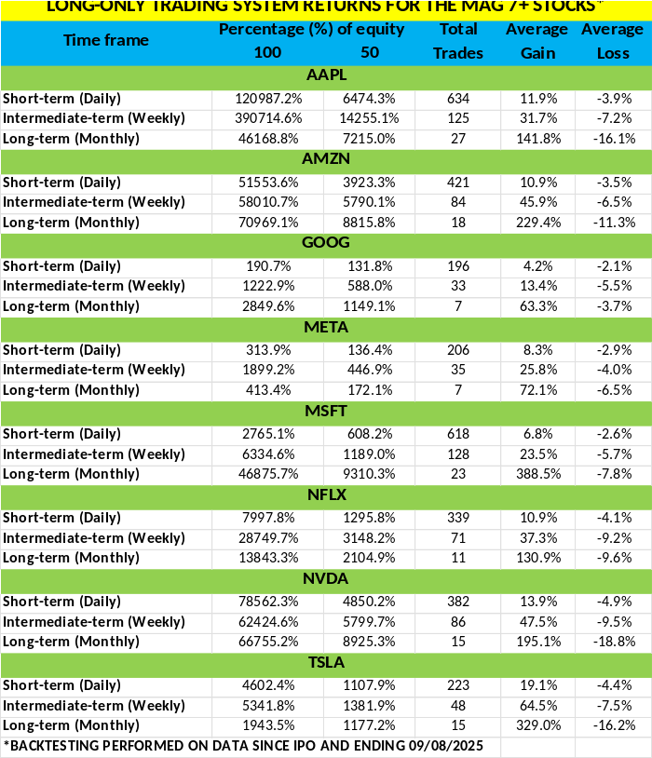
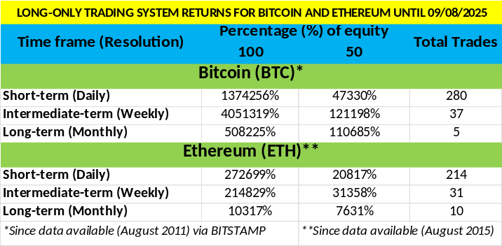
The code for these trading systems is available for purchase. Please contact us for pricing details. It is written in Pine Script and can be directly integrated into TradingView, Alpaca, or Interactive Brokers (IBKR), allowing it to manage all your trading needs. Any AI, such as GROK or ChatGPT, can quickly modify the code to another language if necessary.
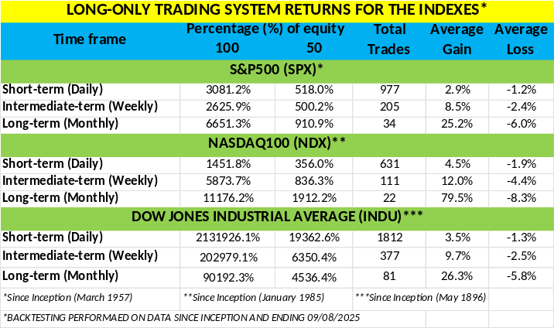
*Past performance is no guarantee of future results. The trading systems' signals are derived from data believed to be accurate, but such accuracy or completeness cannot be guaranteed. It should not be assumed that such signals, past or future, will be profitable, equal past performance, or ensure future performance or trends, primarily since a human writes these emails and may contain errors and omissions. LAST GENERATED 09/09/2025.

REFERAL PROGRAM

For every person you refer who signs up for our top-tier newsletter and pays the trial fee of $49.99, you earn a 50% discount on your next monthly payment, worth up to $49.99. Invite family, friends, colleagues, neighbors, or anyone interested in the financial markets and eager to stay ahead. If you refer two people each month, your discount covers 100% of your next payment. And if you refer more than two, you can start earning money!

After signing up, all referrals must send us an email that includes your name and email address so that we can verify this information against our records.

Spread the word!

This copyrighted MATERIAL is intended solely for use by designated recipients. No reproduction, retransmission, or other use of the information or images is authorized. Legitimate news media may quote representative passages to report on my opinions in context and with full attribution. The analysis is derived from data believed to be accurate, but such accuracy or completeness cannot be guaranteed. It should not be assumed that such ANALYSIS, PAST or FUTURE, WILL be profitable, equal past performance, or guarantee future performance or trends. All TRADING and investment decisions are the sole responsibility of the reader. Including information about managed ACCOUNTS, PROGRAM positions, and other information is not intended to be a recommendation or solicitation. For more INFORMATION, CONTACT Intelligent Investing, LCC, at info@intelligentinvesting.market. I reserve the right to refuse service to anyone for any reasON.

